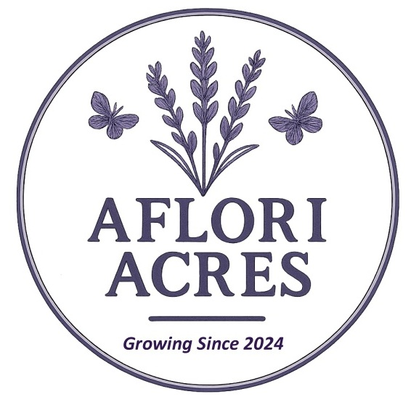
AFLORI ACRES – VENDOR INSURANCE HANDOUT
Grand Opening – July 11, 2026
7 Osborne Rd
Athens, Ontario
GENERAL
Thank you for applying to be a vendor at the Aflori Acres Grand Opening,
a community celebration marking the launch of Athens’ first lavender field.

This event is hosted by Aflori Acres and supported by local volunteers. Vendor fees help cover event operations and visitor services.

The safety of our visitors, vendors, exhibitors, and volunteers is a top priority. Proper insurance ensures a safe and well‑managed event for everyone.

INSURANCE REQUIREMENTS
Aflori Acres carries general event insurance; however, all vendors must have their own liability insurance to cover personal liability, property damage, theft, and any vendor‑related incidents.

As stated in the Vendor Application Form, proof of insurance is required to participate.

DUUO PARTNERSHIP
Aflori Acres has partnered with DUUO (Cooperators).
You can purchase day‑of vendor insurance quickly and easily.
Creating an account is easy

Most policies are typically under $20.
DUUO will email you a copy of your certificate.
Please forward to afloriacres@gmail.com
If you cancel your policy, you will not be able to attend as a vendor.
As below please add Leeds and Grenville township and Athens township to your policy.

PERSONAL OR BUSINESS INSURANCE
If you already carry your own vendor insurance, you may use it instead of DUUO.
Your insurance certificate must list the following as additional insured:

Township of Athens
1 Maint street W
Athens, Ontario
K0E 1B0

Leeds and Grenville Township
25 Central Ave W Suite 100
Brockville, ON
K6V 4N6

Aflori Acres
& Osborne Rd
Athens, Ontario
K0E 1B0

Please email your personal insurance certificate to:
afloriacres@gmail.com by May 1, 2026 along with payment

Important:
Vendors who do not provide valid insurance with the required additional insured cannot attend the event, and vendor fees will not be refunded.

